**Programming Fundamentals**

**Lab Task Week 5**

**Athar Abbas**

SP25-BSE-082

Section - A

**Task 1:** Even or Odd

**1 #include *<iostream>***

**2 #include *<iomanip>***

**3 using namespace std;**

**4 int main() {**

**5 cout << "Even or Odd" << endl;**

**6 int x;**

**7 cout << "Input the number to check" << endl;**

**8 cin >> x;**

**9 cout << setw(25) << setfill('=') << '=' << endl;**

**10 if (x % 2 == 0){**

**11 cout << "Number is Even" << endl;**

**12 }**

**13 else{**

**14 cout << "Number is Odd" << endl;**

**15 }**

**16 return 0;}**

**Output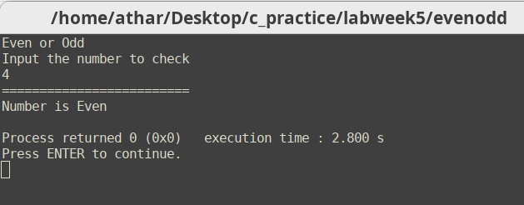:**

**Task 2:** 24 Hour format to 12 Hour format

1 **#include *<iostream>***

**2 #include *<iomanip>***

**3 using namespace std;**

**4 int main () {**

**5 int itimeh , itimem , itimes;**

**6 cout << "Input the time in 24 hour format" << endl;**

**7 cout << "Hours: ";**

**8 cin >> itimeh;**

**9 cout << "Minutes: ";**

**10 cin >> itimem;**

**11 cout << "Seconds: ";**

**12 cin >> itimes;**

**13 cout << endl;**

**14 cout << setw(25) << setfill('=') << '=' << endl;**

**15 cout << endl;**

**16 cout << "Time in 12 hour format" << endl;**

**17 int ntimeh;**

**18 if (itimeh <= 12) {**

**19 cout << itimeh << ":" << itimem << ":" << itimes << endl;**

**20 }**

**21 if (itimeh > 12) {**

**22 ntimeh = itimeh - 12;**

**23 cout << ntimeh << ":" << itimem << ":" << itimes << endl;**

**24 }**

**25 return 0;}**

**Output:**

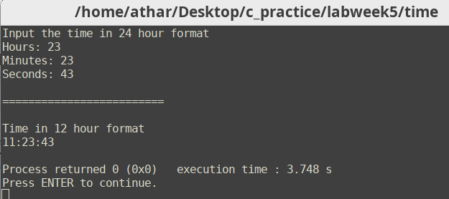

**Task 3:** Sum of Positive Integers

**1 #include *<iostream>***

**2 #include *<iomanip>***

**3 using namespace std;**

**4 int main() {**

**5 cout << "Input three numbers" << endl;**

**6 int num1,num2,num3;**

**7**

**8 cout << "First num: ";**

**9 cin >> num1;**

**10 cout << "Second num: ";**

**11 cin >> num2;**

**12 cout << "Third num: ";**

**13 cin >> num3;**

**14 cout << endl;**

**15 cout << setw(25) << setfill('=') << '=' << endl;**

**16 int sum = 0;**

**17 if (num1 >= 0) {**

**18 sum += num1;**

**19 }**

**20 if (num2 >= 0){**

**21 sum += num2;**

**22**

**23 }**

**24 if (num3 >= 0) {**

**25 sum += num3;**

**26 }**

**27**

**28 cout << "The Sum of the positive integers is " << sum << endl;**

**29 return 0;**

**30 }**

**Output:**

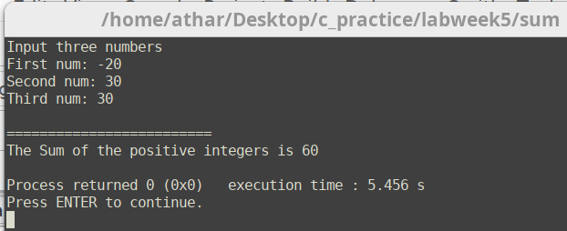

**Task 4:** Valid and Invalid Triangle

**1 #include *<iostream>***

**2 #include *<iomanip>***

**3 using namespace std;**

**4 int main() {**

**5 cout << "Input the three angles" << endl;**

**6 double num1,num2,num3;**

**7**

**8 cout << "Angle a: ";**

**9 cin >> num1;**

**10 cout << "Angle 𝛃: ";**

**11 cin >> num2;**

**12 cout << "Angle y: ";**

**13 cin >> num3;**

**14 double sum = num1 + num2 + num3;**

**15 cout << setw(25) << setfill('=') << '=' << endl;**

**16 if (sum == 180 ) {**

**17 cout << "Triangle is Valid" << endl;**

**18 } else {**

**19 cout << "Invalid Triangle" << endl;**

**20 }**

21 }

**Output:**

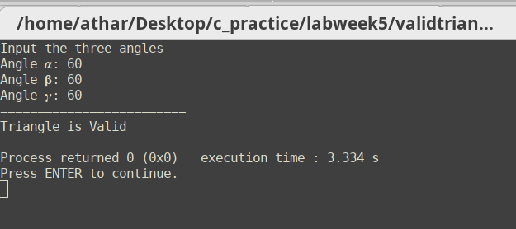 **Task 5:** Sum, Product , Average and Comparison

**1 #include *<iostream>***

**2 #include *<iomanip>***

**3 using namespace std;**

**4 int main() {**

**5 cout << "Input three numbers" << endl;**

**6 int num1,num2,num3;**

**7**

**8 cout << "First num: ";**

**9 cin >> num1;**

**10 cout << "Second num: ";**

**11 cin >> num2;**

**12 cout << "Third num: ";**

**13 cin >> num3;**

**14 cout << endl;**

**15 cout << setw(25) << setfill('=') << '=' << endl;**

**16 cout << "The Sum of the numbers is " << num1+num2+num3 << endl;**

**17 cout << "The Product of the numbers is " << num1*num2*num3 << endl;**

**18 cout << "The average of the numbers is " << (num1+num2+num3) / 3 << endl;**

**19 int big = (num1 >= num2) ? num1 : num2;**

**20 int bigger = (big >= num3) ? big : num3;**

**21 cout << "The largest number is " << bigger << endl;**

**22 int small = (num1 <= num2) ? num1 : num2;**

**23 int smaller = (small <= num3) ? small : num3;**

**24 cout << "The smallest number is " << smaller << endl;**

25 return 0;}

**Output:**

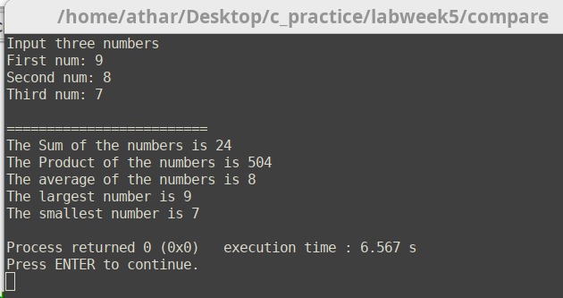

**Task 6:** Case Check

**1 #include *<iostream>***

**2 #include *<iomanip>***

**3 using namespace std;**

**4 int main() {**

**5 char x;**

**6 cout << "Input the character" << endl;**

**7 cin >> x;**

**8 cout << endl;**

**9 cout << setw(25) << setfill('=') << '=' << endl;**

**10 cout << endl;**

**11 if (isupper(x)) {**

**12 cout << "Uppercase Alphabet" << endl;**

**13**

**14 } else {**

**15 cout << "Lowercase Alphabet" << endl;**

**16 }**

**17 return 0;**

**18 }**

**Output:**

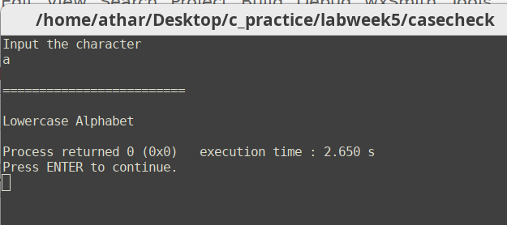

**Task 7:** Number to Word

**1 #include *<iostream>***

**2 #include *<iomanip>***

**3 using namespace std;**

**4 int main() {**

**5 cout << "Number to word" << endl;**

**6 int num;**

**7 cout << "Input a number (0-9)" << endl;**

**8 cin >> num;cout << setw(25) << setfill('=') << '=' << endl;**

**9 if (num == 0){**

**10 cout << "Zero" << endl;**

**11 }**

**12**

**13 else if (num == 1) {**

**14 cout << "One" << endl;**

**15 }**

**16 else if (num == 2) {**

**17 cout << "Two" << endl;**

**18 }**

**19 else if (num == 3) {**

**20 cout << "Three" << endl;**

**21 }**

**22 else if (num == 4) {**

**23 cout << "Four" << endl;**

**24 }**

**25 else if (num == 5) {**

**26 cout << "Five" << endl;**

**27 }**

**28 else if (num == 6) {**

**29 cout << "Six" << endl;**

**30 }**

**31 else if (num == 7) {**

**32 cout << "Seven" << endl;**

**33 }**

**34 else if (num == 8) {**

**35 cout << "Eight" << endl;**

**36 }**

**37 else if (num == 9) {**

**38 cout <<"Nine" << endl;**

**39 }**

**40 else{**

**41 cout << "Please input a Number between 0 and 9" << endl;**

**42 }**

**43 return 0;}**

**Output:**

